Gravitational Waves Detected, Confirming Einstein’s Theory

Dennis Overbye

A team of scientists announced on Thursday that they had heard and recorded the sound of two black holes colliding a billion light-years away, a fleeting chirp that fulfilled the last prediction of Einstein’s general theory of relativity.

That faint rising tone, physicists say, is the first direct evidence of gravitational waves, the ripples in the fabric of space-time that Einstein predicted a century ago. (Listen to it here.) It completes his vision of a universe in which space and time are interwoven and dynamic, able to stretch, shrink and jiggle. And it is a ringing confirmation of the nature of black holes, the bottomless gravitational pits from which not even light can escape, which were the most foreboding (and unwelcome) part of his theory.

More generally, it means that a century of innovation, testing, questioning and plain hard work after Einstein imagined it on paper, scientists have finally tapped into the deepest register of physical reality, where the weirdest and wildest implications of Einstein’s universe become manifest.

Conveyed by these gravitational waves, power 50 times greater than the output of all the stars in the universe combined vibrated a pair of L-shaped antennas in Washington State and Louisiana known as LIGO on Sept. 14.

If replicated by future experiments, that simple chirp, which rose to the note of middle C before abruptly stopping, seems destined to take its place among the great sound bites of science, ranking with Alexander Graham Bell’s “Mr. Watson — come here” and Sputnik’s first beeps from orbit.

“We are all over the moon and back,” said Gabriela González of Louisiana State University, a spokeswoman for the LIGO Scientific Collaboration, short for Laser Interferometer Gravitational-Wave Observatory. “Einstein would be very happy, I think.”

Members of the LIGO group, a worldwide team of scientists, along with scientists from a European team known as the Virgo Collaboration, published a report in Physical Review Letters on Thursday with more than 1,000 authors.
“I think this will be one of the major breakthroughs in physics for a long time,” said Szabolcs Marka, a Columbia University professor who is one of the LIGO scientists.

“Everything else in astronomy is like the eye,” he said, referring to the panoply of telescopes that have given stargazers access to more and more of the electromagnetic spectrum and the ability to peer deeper and deeper into space and time. “Finally, astronomy grew ears. We never had ears before.”

Long-Awaited Triumph
The discovery is a great triumph for three physicists — Kip Thorne of the California Institute of Technology, Rainer Weiss of the Massachusetts Institute of Technology and Ronald Drever, formerly of Caltech and now retired in Scotland — who bet their careers on the dream of measuring the most ineffable of Einstein’s notions.
Photo


Important players in the LIGO project, from left to right: Kip Thorne of the California Institute of Technology, France A. Córdova of the National Science Foundation, Rainer Weiss of the Massachusetts Institute of Technology, David Reitze of Caltech and Gabriela González of Louisiana State University.
Credit
Lexey Swall for The New York Times

“Until now, we scientists have only seen warped space-time when it’s calm,” Dr. Thorne said in an email. “It’s as though we had only seen the ocean’s surface on a calm day but had never seen it roiled in a storm, with crashing waves.”

The black holes that LIGO observed created a storm “in which the flow of time speeded, then slowed, then speeded,” he said. “A storm with space bending this way, then that.”

The chirp is also sweet vindication for the National Science Foundation, which spent about $1.1 billion over more than 40 years to build a new hotline to nature, facing down criticism that sources of gravitational waves were not plentiful or loud enough to justify the cost.

“It’s been decades, through a lot of different technological innovations,” France Córdova, the foundation’s director, said in an interview, recalling how, in the early years, the foundation’s advisory board had “really scratched their heads on this one.”

Word of LIGO’s success was met by hosannas in the scientific community, albeit with the requisite admonishments of the need for confirmation or replication.
“I was freaking out,” said Janna Levin, a theorist at Barnard College at Columbia who was not part of LIGO but was granted an early look at the results for her warts-and-all book about the project, “Black Hole Blues,” to be published this spring.

Robert Garisto, the editor of Physical Review Letters, said he had gotten goose bumps while reading the LIGO paper.

Elusive Disturbances
When Einstein announced his theory in 1915, he rewrote the rules for space and time that had prevailed for more than 200 years, since the time of Newton, stipulating a static and fixed framework for the universe. Instead, Einstein said, matter and energy distort the geometry of the universe in the way a heavy sleeper causes a mattress to sag, producing the effect we call gravity.
- 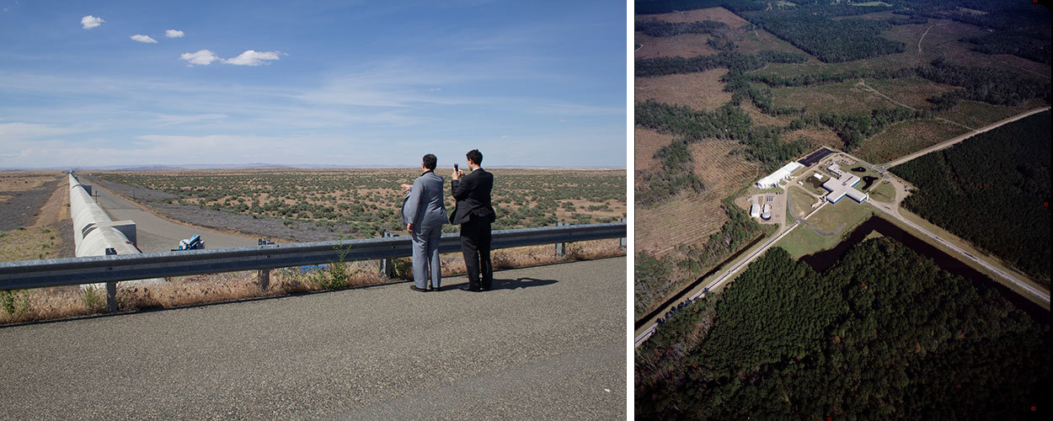

A pair of L-shaped antennas, known as LIGO, in Hanford, Wash., left, and Livingston, La., detected the gravitational waves on Sept. 14.
Credit
Caltech-M.I.T.-LIGO Lab

A disturbance in the cosmos could cause space-time to stretch, collapse and even jiggle, like a mattress shaking when that sleeper rolls over, producing ripples of gravity: gravitational waves.

Einstein was not quite sure about these waves. In 1916, he told Karl Schwarzschild, the discoverer of black holes, that gravitational waves did not exist, then said they did. In 1936, he and his assistant Nathan Rosen set out to publish a paper debunking the idea before doing the same flip-flop again.

According to the equations physicists have settled on, gravitational waves would compress space in one direction and stretch it in another as they traveled outward.

In 1969, Joseph Weber, a physicist at the University of Maryland, claimed to have detected gravitational waves using a six-foot-long aluminum cylinder as an antenna. Waves of the right frequency would make the cylinder ring like a tuning fork, he said.

Others could not duplicate his result, but few doubted that gravitational waves were real. Dr. Weber’s experiment inspired a generation of scientists to look harder for Einsteinian marks on the universe.
In 1978, the radio astronomers Joseph H. Taylor Jr. and Russell A. Hulse, then at the University of Massachusetts Amherst, discovered a pair of neutron stars, superdense remnants of dead stars, orbiting each other. One of them was a pulsar, emitting a periodic beam of electromagnetic radiation. By timing its pulses, the astronomers determined that the stars were losing energy and falling closer together at precisely the rate that would be expected if they were radiating gravitational waves.

NEWS CLIPS: 1:37Gravitational Waves

Dr. Hulse and Dr. Taylor won the Nobel Prize in Physics in 1993.
Another group of astronomers who go by the name Bicep made headlines in 2014 when they claimed to have detected gravitational waves from the beginning of the Big Bang, using a telescope at the South Pole. They later acknowledged that their observations had probably been contaminated by interstellar stardust.

A Quixotic Project
Dr. Thorne of Caltech and Dr. Weiss of M.I.T. first met in 1975, Dr. Weiss said, when they had to share a hotel room during a meeting in Washington. Dr. Thorne was already a renowned black-hole theorist, but he was looking for new experimental territory to conquer. They stayed up all night talking about how to test general relativity and debating how best to search for gravitational waves.

Dr. Thorne then recruited Dr. Drever, a gifted experimentalist from the University of Glasgow, to start a gravitational wave program at Caltech. Dr. Drever wanted to use light — laser beams bouncing between precisely positioned mirrors — to detect the squeeze and stretch of a passing wave.

Dr. Weiss tried to mount a similar effort at M.I.T., also using the laser approach, but at the time, black holes were not in fashion there. (Things are better now, he said.)

The technological odds were against both efforts. The researchers calculated that a typical gravitational wave from out in space would change the distance between a pair of mirrors by an almost imperceptible amount: one part in a billion trillion. Dr. Weiss recalled that when he explained the experiment to his potential funders at the National Science Foundation, “everybody thought we were out of our minds.”

In 1984, to the annoyance of Dr. Drever and the relief of Dr. Weiss, the National Science Foundation ordered the two teams to merge. Dr. Thorne found himself in the dual roles of evangelist for the field of gravitational waves and broker for experimental disagreements.

Progress was slow until the three physicists were replaced in 1987 by a single director as part of the price of going forward.
The first version of the experiment, known as Initial LIGO, started in 2000 and ran for 10 years, mostly to show that it could work on the scale needed. There are two detectors: one in Hanford, Wash., the other in Livingston, La. Hunters once shot up the outside of one of the antenna arms in Louisiana, and a truck crashed into one of the arms in Hanford. In neither case was the experiment damaged.

Over the last five years, the entire system was rebuilt to increase its sensitivity to the point where the team could realistically expect to hear something.

LIGO’s antennas are L-shaped, with perpendicular arms 2.5 miles long. Inside each arm, cocooned in layers of steel and concrete, runs the world’s largest bottle of nothing, a vacuum chamber a couple of feet wide containing 2.5 million gallons of empty space. At the end of each arm are mirrors hanging by glass threads, isolated from the bumps and shrieks of the environment better than any Rolls-Royce ever conceived.

Thus coddled, the lasers in the present incarnation, known as Advanced LIGO, can detect changes in the length of one of those arms as small as one ten-thousandth the diameter of a proton — a subatomic particle too small to be seen by even the most powerful microscopes — as a gravitational wave sweeps through.

An Earthling’s Guide to Black Holes
Welcome to the place of no return — a region in space where the gravitational pull is so strong that not even light can escape it. This is a black hole.
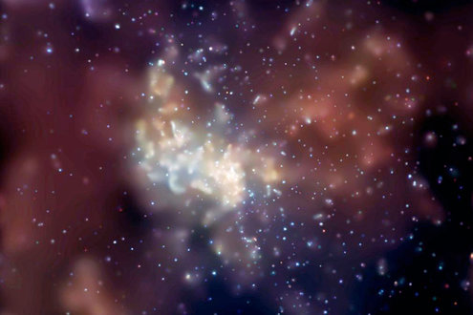

Even with such extreme sensitivity, only the most massive and violent events out there would be loud enough to make the detectors ring. LIGO was designed to catch collisions of neutron stars, which can produce the violent flashes known as gamma ray bursts.

As they got closer together, these neutron stars would swing around faster and faster, hundreds of times a second, vibrating space-time geometry with a rising tone that would be audible in LIGO’s vacuum-tube “sweet spot.”

Black holes, the even-more-extreme remains of dead stars, could be expected to do the same, but nobody knew if they existed in pairs or how often they might collide. If they did, however, the waves from the collision would be far louder and lower pitched than those from neutron stars.

Dr. Thorne and others long thought these would be the first waves to be heard by LIGO. But even he did not expect it would happen so quickly.

‘It Was Waving Hello’
On Sept. 14, the system had barely finished being calibrated and was in what is called an engineering run at 4 a.m. when a loud signal came through at the Livingston site. “Data was streaming, and then ‘bam,’ ” recalled David Reitze, a Caltech professor who is the director of the LIGO Laboratory, the group that built and runs the detectors.

Seven milliseconds later, the signal hit the Hanford site. LIGO scientists later determined that the likelihood of such signals landing simultaneously by pure chance was vanishingly small. Nobody was awake in the United States, but computers tagged the event, and European colleagues noticed.

What Is General Relativity?
Einstein presented his general theory of relativity 100 years ago this month.
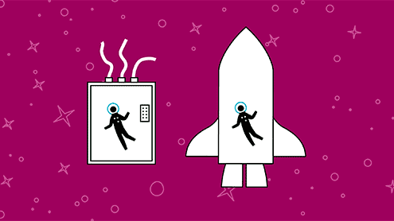
OPEN GRAPHIC

Dr. Reitze was on a plane to Louisiana the next day. Dr. Weiss, on vacation in Maine, found out when he checked in by computer that morning. “It was waving hello,” he said. “It was amazing. The signal was so big, I didn’t believe it.”

The frequency of the chirp was too low for neutron stars, the physicists knew. Detailed analysis of its form told a tale of Brobdingnagian activities in a far corner of the universe: the last waltz of a pair of black holes shockingly larger than astrophysicists had been expecting.

One of them was 36 times as massive as the sun, the other 29. As they approached the end, at half the speed of light, they were circling each other 250 times a second.

And then the ringing stopped as the two holes coalesced into a single black hole, a trapdoor in space with the equivalent mass of 62 suns. All in a fifth of a second, Earth time.

Dr. Weiss said you could reproduce the chirp by running your fingernails across the keys of a piano from the low end to middle C.

Lost in the transformation was three solar masses’ worth of energy, vaporized into gravitational waves in an unseen and barely felt apocalypse. As visible light, that energy would be equivalent to the brightness of a billion trillion suns.
And yet it moved the LIGO mirrors only four one-thousandths of the diameter of a proton.
The signal conformed precisely to the predictions of general relativity for black holes as calculated in computer simulations, Dr. Reitze said.

Shortly after the September event, LIGO recorded another, weaker signal that was probably also from black holes, the team said. According to Dr. Weiss, there were at least four detections during the first LIGO observing run, which ended in January. The second run will begin this summer. In the fall, another detector, Advanced Virgo, operated by the European Gravitational Observatory in Italy, will start up. There are hopes for more in the future, in India and Japan.

Looking Forward
Astronomers now know that pairs of black holes do exist in the universe, and they are rushing to explain how they got so big. According to Vicky Kalogera of Northwestern University, there are two contenders right now: Earlier in the universe, stars lacking elements heavier than helium could have grown to galumphing sizes and then collapsed straight into black holes without the fireworks of a supernova explosion, the method by which other stars say goodbye. Or it could be that in the dense gatherings of stars known as globular clusters, black holes sink to the center and merge.

Michael S. Turner, a cosmologist at the University of Chicago, noted that astronomers had once referred to the search for gravitational waves as an experiment, not an observatory. “LIGO has earned its ‘O,’ ” he said. “That is, it will be an observatory, getting tens of events per year.”

Hearing a Gravitational Wave
Predicted by Einstein’s general theory of relativity 100 years ago, gravitational waves have been directly detected for the first time. LIGO, the Laser Interferometer Gravitational-Wave Observatory, heard black holes colliding.

HOW ASTRONOMEY GREW ITS EARS?
Zsuzsa Marka, Hungarian Scientist
Columbia Experimental Gravity Group
Columbia University in the City of New York
Presentation at theHungarian Consulate, New York, March 2016
